18th Annual Queen of Pink Pageant
Saturday, June 8, 2024
Location: CFMA building located at 3481 East Prien Lake Road, Lake Charles

Early Bird Entry Fee: $50.00 by May 6, 2024
Entry Fee: $60.00 by Thursday, June 6, 2024 – Entry Fee at Door will be $70 Cash Only
Entry fee includes photogenic and side awards.

Registration: 9:00 – 9:30 AM Competition: 10:00 AM
Attire: Sunday Best
Baby Miss: 0 – 11 months Toddler Miss: 12-23 months T’Nincy Miss: 2 years Tiny Miss: 3 years
Mini Miss: 4 years Petite Miss: 5-6 years Little Miss: 7-8 years

Registration: 2:00 – 2:30 PM Competition: 3:00 PM
Attire: Dress or Pant Suit
Survivor: Breast Cancer Survivors *FREE ENTRY* Classic: 40 years & up

Attire: Long Formal
Deb Miss: 9– 10 years Young Miss: 11-12 years Teen Miss: 13-14 years
Lady: 21 years & up (size 16 & up) MS: 21 years & up (married/divorced/mom)
Junior Miss: 15-16 years

Miss Queen of Pink (17-23 years) *Contracted title* Registration: 12:30-1:00pm
****Miss Constestant must reside in Calcasieu, Cameron, Jeff Davis, Beauregard, or Allen Parish****
Interview Competition: 1:30pm Attire: Nice blue jeans with Queen of Pink t-shirt and taupe heels
Miss Contestants will be given their t-shirt when entry is paid so that they may bling it to show their personality.
Onstage Competition: 4:00pm Attire: Long Formal
**Introduction will be required for Miss Contestants only. (Greeting, name & contestant number) **

Queens will receive a custom Queen of Pink crown and embroidered banner.
Division awards: Side Awards: certificate --- Most Photogenic: trophy --- 1st, 2nd, & 3rd alternates: certificate
All contestants will receive a participation gift.
Side Awards include: Best Hair, Prettiest Eyes, Best Personality/Modeling, Best Smile, and Best Fashion

All proceeds from the pageant go to the Queen of Pink Organization, a non-profit organization whose purpose is to help Southwest Louisiana breast cancer patients in financial need to pay for treatments and other expenses.
The organization gives a $500 gift every month to help someone with breast cancer.
This is made possible through fundraisers and donations.

Awards are given to contestants that raise donations for the Queen of Pink organization.
(Entry fee is not included in donation amount.)
***A donation form is attached to this entry form to help with collecting donations***
Donation Award: Any contestant raising $100 or more in donations will receive a certificate and gift.
Princess of Pink: Any contestant raising $400 or more in donations will receive a certificate, gift, custom monogrammed banner, and a pink ribbon crown. If not competing, you may raise $500 in donations and be crowned Princess of Pink.
Prince of Pink: Any boy raising $400 or more in donations will receive a certificate, gift, custom monogrammed banner, and a crown.
Ambassador of Pink: The contestant raising the most donations will receive a certificate, gift, and a custom Queen of Pink crown and monogrammed banner.
**DEADLINE: DONATIONS MUST BE RECEIVED BY MAY 6, 2024**

***All Queens and Princesses ARE REQUIRED to stay until the end of their pageant session
for group pictures and a short meeting with the director to sign a behavior contract. ***
***ALL 2024 QUEEN OF PINK ROYALTY ARE REQUIRED TO ATTEND
THE QUEEN OF PINK WALK & BENEFIT ON OCTOBER 5, 2024 IN MOSS BLUFF, LA
and to attend at least 1 Queen of Pink bake sale in the months of August and September***

*FOR MORE INFORMATION: Joyce Bennett: 337-842-1448 or Susan Landry 337-515-1492
Email: queenofpinkpageant@aol.com

RULES AND GENERAL INFORMATION

- Doors will open at 7:30AM the day of pageant. Door admission is $5 for everyone over 3 years of age, except contestants. (CASH ONLY) Visiting Queens are admitted free with crown and banner.

- Photogenic entries (only 1 photo) should be turned in the day of the pageant during registration. Please label the back of the photo with the contestant’s first name and age. (No picture frames and no cell phone pictures.) Photo should be no larger than 8X10 and may be color or black and white.

- DRESSING ROOMS: No males over the age of 5 will be allowed in the dressing rooms at any time. NO exceptions. Please keep dressing rooms clean by disposing of all trash.

- Scores will not be posted at the pageant. Scores will be emailed to the email address provided on entry form within 2 weeks after the pageant.

- Contestant must compete in the division for their age according to the date of the pageant. If contestant’s age is questioned, parent must provide a copy of birth certificate to prove date of birth. If any information on the application is false, contestant will be required to forfeit any prizes/title won to the pageant director and will be banned from future Queen of Pink pageants. 2023 Royalty may compete if they age up into next division with the exception of Miss, MS, Lady, and Classic divisions. Any past MS, Lady, Survivor, or Classic contestants may recompete in their division 5 years after they crown their successor.

- Pageant hair and makeup is allowed, but not required and must be age appropriate. NO GLITZ! Fake eyelashes are allowed for ages 9 and up but are not required. Judges will be told to judge according to the child’s age. Dress code must be adhered to. Dress does NOT have to be pink.

- Modeling will be basic “T” formation with 3 X’s in front of the judges. Judging will be on beauty, attire, personality(0-3)/modeling(4&up), and overall appearance. Miss contestants will also be judged on introduction. Judges Decisions are FINAL!

- Any questions or concerns, please address the directors personally. Bad sportsmanship or any disrespect to Judges, Pageant Directors and helpers, or other contestants/visitors will not be tolerated. You will be disqualified and told to leave without a refund.

- Karen Latiolais Sonnier will be available for pictures. All 2024 Royalty are required to have official photo taken.

- The 2024 Miss Queen of Pink (ages 17-23) will be contracted. The Miss Queen will not be able to compete for or represent any other title & crown and must return to crown her successor at the conclusion of her reign. The Miss Queen will receive a $500.00 scholarship at the end of her reign provided terms of her contract have been met. A copy of the contract will be available to be reviewed at any time before the pageant. The Miss Queen CANNOT be married, divorced, or pregnant and MUST NOT get married or become pregnant during her reign. Contract MUST be signed by newly crowned queen immediately following the pageant. FAILURE TO SIGN CONTRACT WILL RESULT IN DISQUALIFICATION; THEREFORE, MAKING THE FIRST ALTERNATE THE NEW QUEEN!

- 9 year and older royalty will be partially contracted. They will represent their Queen of Pink title and will not compete for another title from the time of crowning until after October 5, 2024. They may hold a previous title when competing as long as it does not conflict with the Queen of Pink Breast Cancer Awareness Walk and Benefit on October 5, 2024.

- All 2024 Queen of Pink Royalty must sign an agreement that they will attend 1 fundraiser for the Queen of Pink Organization in the months of August and September and promote and attend the Queen of Pink Breast Cancer Awareness Walk and Benefit on October 5, 2024, in Moss Bluff, LA, and will be properly dressed, groomed and behaved while representing the Queen of Pink Organization at all times during her reign and abide by the conditions of this contract or she will forfeit her title and all prizes to the Pageant Committee. Please contact director for a copy of contract to review.

If you have any questions, please email queenofpinkpageant@aol.com
Or contact Joyce Bennett at 337-842-1448 or Susan Landry at 337-515-1492

Survivor Contestants Only:
Date of Diagnosis: ___/___/___
18th Annual Queen of Pink Pageant

Contestant #: _____ Division: _________________ Please type or print neatly
Name: ______________________________________________________________________________________________
Date of Birth: _____/_____/_____ Age Day of Pageant: _____ T-shirt Size: _______________ please specify if Adult or Child size
Parents/Guardian: _____________________________________________________________________________________
Mailing Address: _________________________________ City: ____________________ State: ______ Zip: ___________
Cell Phone #: ____________________ Email Address: _______________________________________________________
School: ________________________________________________________________________Grade: ______________
Hair Color: _______________________ Eye Color: ____________________ Favorite Color: ________________________
Ambition: ___________________________________________________________________________________________
Hobbies: ____________________________________________________________________________________________
____________________________________________________________________________________________________
Organizations, Clubs, Honors, and Awards: _________________________________________________________________
____________________________________________________________________________________________________
Most Admired Person and why: __________________________________________________________________________
____________________________________________________________________________________________________
Sponsored By: _______________________________________________________________________________________
Mail/Email forms and payments to:

Queen of Pink
Po Box 409
Iowa, LA 70647
Email and *PayPal:
Queenofpink2006@aol.com

*If paying by PayPal, please put the contestant’s name, age, parent name, and email in the memo area.
*Make sure to use Family and Friends or you will be responsible for fees.
**Please Make Checks Payable to QUEEN OF PINK** any checks returned for NSF will be charged a $25 fee.
NO REFUNDS
I agree that the Queen of Pink Pageant Committee, the Queen of Pink Organization, or the Cajun French Music Association will not be held responsible for accidents, injury, theft, or loss that may occur before, during, or after this event to me or my guests and to always conduct myself in appropriate manner becoming my title. I also agree to abide by all rules set forth in the application to compete. Any unsportsmanlike conduct will not be tolerated, and you will be asked to leave without a refund. I also give the pageant committee permission to use any photos taken of me during the pageant and/or walk/benefit for publishing on their website and/or for promotional and advertisement purposes. If crowned Queen, I agree to promote and attend the 2024 Queen of Pink Walk & Benefit to be held on October 5, 2024 in Moss Bluff, LA. I also acknowledge that; I will be a representative of the Queen of Pink Organization and agree to represent this title. I agree to attend at least 1 fundraiser associated with the Queen of Pink Organization in the months of August and September. If I do not promote and attend the 2024 Queen of Pink Walk & Benefit, or at any time my behavior and/or appearance is unbecoming to my title, I understand that I will be required to relinquish the Title, Crown, and Banner to the director in the condition I received it. I have read ALL the rules, regulations, and general information and the information on this entry form is true and correct to the best of my knowledge.

____________________________________________________ ________________________________________________________________
Signature of Contestant Date Signature of Parent (If Participant under 18) Date
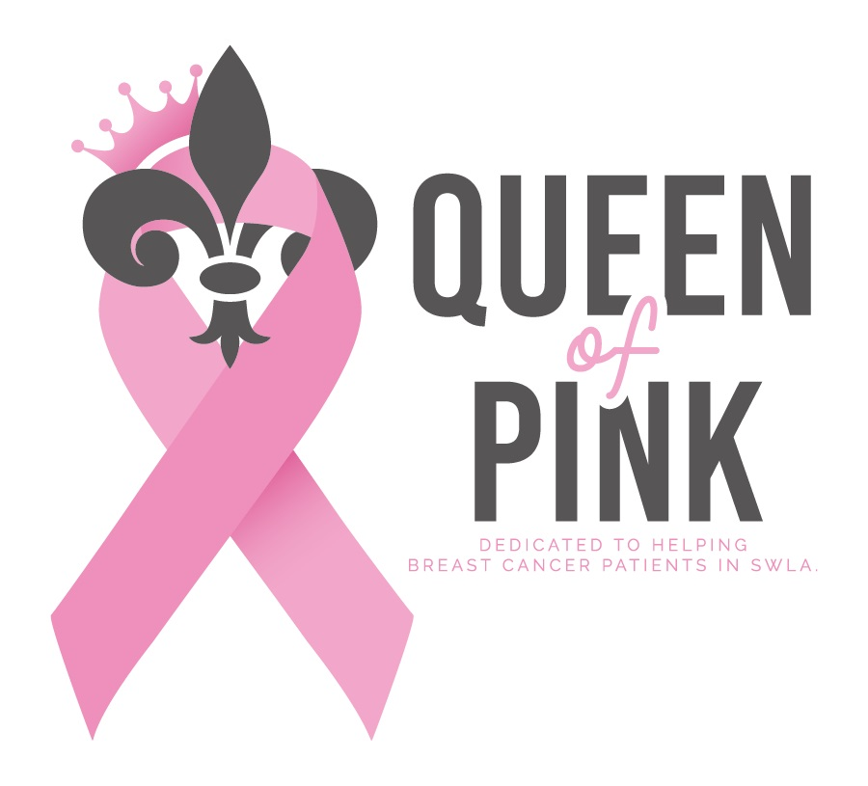
Donation form for the Queen of Pink Organization.
All proceeds go to breast cancer patients in Southwest Louisiana.

Name of Contestant being sponsored___________________________.
Deadline is May 6, 2024

Please mail this form and your donation check to:
Queen of Pink
PO BOX 409
IOWA LA 70647

Name/Business Name: __________________________________________________________________

Mailing Address: ___________________________________________________________________

_____________________________________________________________________________

Email address: __________________________________________________________________

Phone #: ____________________________

Enclosed is my check in the amount of $________________ payable to Queen of Pink.
Please check one: _____No receipt needed _____Email receipt _____Mail receipt

Type of Donation (please choose one):

- General Donation – Business donation (please attach business card if available)

- Gift in memory of: ___________________________________________________________
(Name of deceased)

- Gift in honor of: _____________________________________________________________
(Name of individual)

Sign__________________________________________________ Date____________________

Recognition of your generosity will be posted on our website: www.queenofpink.org
------------------------------------------------------------------------------------------------------------------------------------------

Thank you for your contribution to the Queen of Pink Organization, a 501c3 nonprofit organization.
EIN Number: 26-0750103
Your contribution is tax-deductible to the extent allowed by law.

