20th Annual Queen of Pink Pageant
Saturday, June 20, 2026
Location: Water’s Edge Church, 2760 Power Center Pkwy., Lake Charles, LA 70607

Early Bird Entry Fee: $50.00 by May 1, 2026
Entry Fee: $60.00 by Thursday, June 18, 2026 – Entry Fee at Door will be $70 Cash Only
Entry fee includes photogenic and side awards.
All proceeds from the pageant go to the Queen of Pink Organization, a non-profit organization whose purpose is to help Southwest Louisiana breast cancer patients in financial need to pay for treatments and other expenses.
The organization gives a $500 donation each month to a breast cancer patient in SWLA.

Registration: 9:00 – 9:30 AM Session 1 Competition: 10:00 AM
Attire: Sunday Best / Silk Smock:
Infant Miss: 0 – 6 months Baby Miss: 7 – 11 months Toddler Miss: 12-23 months T’Nincy Miss: 2 years
Tiny Miss: 3 years Mini Miss: 4 years Petite Miss: 5-6 years Little Miss: 7-8 years

Registration: 2:00 – 2:30 PM Session 2 Competition: 3:00 PM
Ages 15 and up are partially contracted. www.queenofpink.org for more information.
Attire: Dress or Pant Suit
Survivor: Breast Cancer Survivors *FREE ENTRY* Classic: 40 years & up

Attire: Long Formal
Deb Miss: 9– 10 years Young Miss: 11-12 years Teen Miss: 13-14 years
Lady: 19 years & up (size 16 & up) MS: 19 years & up (single/married/divorced/mom)
Junior Miss: 15-16 years

Miss Queen of Pink (17-23 years) *Contracted title* Registration: 12:30-1:00pm
****Miss Contestants must reside in Calcasieu, Cameron, Jeff Davis, Beauregard, or Allen Parish****
Interview Competition: 1:30pm Attire: Nice blue jeans with Queen of Pink t-shirt and heels.
Miss Contestants will be given their t-shirt when entry is paid. T-shirt can be blinged
Onstage Competition: 4:00pm Attire: Long Formal
**Introduction will be required for Miss Contestants only. (Greeting, name & contestant number) **

Queens will receive a custom Queen of Pink crown and embroidered banner and t-shirt.
Division awards: Side Awards: certificate --- Most Photogenic: trophy --- 1st, 2nd, & 3rd alternates: certificate
Side Awards include: Best Hair, Prettiest Eyes, Best Personality/Modeling, Best Smile, and Best Fashion
All contestants will receive a participation gift.

Awards are given to contestants that raise donations for the Queen of Pink organization.
(Entry fee is not included in donation amount.)
***A donation form is attached to this entry form to help with collecting donations***
Donation Award: Any contestant raising $200 or more in donations will receive a certificate and gift.
Princess of Pink: Any contestant raising $400 or more in donations will receive a certificate, gift, t-shirt, custom monogrammed banner, and custom Queen of Pink princess crown. If not competing, you may raise $500 in donations and be crowned Princess of Pink.
Ambassador of Pink: The contestant raising the most donations will receive a certificate, gift, t-shirt, and a custom Queen of Pink crown and monogrammed banner.
**DEADLINE: DONATIONS MUST BE RECEIVED BY MAY 10, 2026**

***All Queens and Princesses ARE REQUIRED to stay until the end of their pageant session for group photos and a short meeting with the director to sign a behavior contract. Official group photos will be taken after the evening session***

***ALL 2026 QUEEN OF PINK ROYALTY REQUIREMENTS:
* ATTEND A MANDATORY MEETING, SUNDAY, JULY 19, 2026 IN LAKE CHARLES, LA
*SELL AT LEAST 50 RAFFLE TICKETS***
*ATTEND THE QUEEN OF PINK WALK & BENEFIT ON OCTOBER 10, 2026 IN IOWA, LA
*FOR MORE INFORMATION- Text: Joyce Bennett: 337-842-1448 or Jenna Amy Bennett: 337-540-5124
Email: queenofpinkpageant@aol.com
For all the rules and pageant information please visit our website www.queenofpink.org.

RULES AND GENERAL INFORMATION

- Doors will open at 7:30AM, the day of pageant. Door admission is $5 for everyone over 3 years of age, except contestants. (CASH ONLY) Visiting Queens are admitted free with crown and banner.

- Photogenic entries (only 1 photo) should be turned in the day of the pageant during registration. Please label the back of the photo with the contestant’s first name and age. (No picture frames and no cell phone pictures.) The photo should be no larger than 8X10 and may be color or black and white.

- DRESSING ROOMS: No males will be allowed in the dressing rooms at any time. NO exceptions. Please keep the dressing rooms clean by disposing of all trash.

- Scores will not be posted at the pageant. Scores will be emailed to the email address provided on entry form within 2 weeks after the pageant.

- Contestants must compete in the division for their age according to the date of the pageant. If the contestant’s age is questioned, parents must provide a copy of birth certificate to prove date of birth. If any information on the application is false, contestants will be required to forfeit any prizes/title won to the pageant director and will be banned from future Queen of Pink pageants. 2025 Royalty may compete if they age up into the next division with the exception of Miss, MS, Lady, and Classic divisions. Any past MS, Lady, Survivor, or Classic contestants may recompete in their division 5 years after they crown their successor.

- Pageant hair and makeup is allowed but not required and must be age appropriate. NO GLITZ! Fake eyelashes are allowed for ages 9 and up but are not required. Judges will be told to judge according to the child’s age. The dress code must be adhered to. The dress does NOT have to be pink.

- Modeling will be basic “T” formation with 3 X’s in front of the judges. Judging will be on beauty, attire, personality (0-3)/modeling(4&up), and overall appearance. Miss contestants will also be judged on introduction. Judges Decisions are FINAL!

- Any questions or concerns, please address the directors personally. Bad sportsmanship or any disrespect to Judges, Pageant Directors and helpers, or other contestants/visitors will not be tolerated. You will be disqualified and told to leave without a refund.
- Karen Latiolais Sonnier will be available for pictures. All 2026 Royalty are required to have an official photo taken.
- All 2026 Queen of Pink Royalty must sign an agreement that they will sell at least 50 raffle tickets for the Queen of Pink Organization and promote and attend the Queen of Pink Breast Cancer Awareness Walk and Benefit on October 10, 2026, in Iowa, LA, and will be properly dressed, groomed and behaved while representing the Queen of Pink Organization at all times during her reign and abide by the conditions of this contract or she will forfeit her title and all prizes to the Pageant Committee,
- 15 year and older royalty will be partially contracted. They will represent their Queen of Pink title and will not compete for another title from the time of crowning until after October 10, 2026. They may hold a previous title when competing as long as it does not conflict with the Queen of Pink Breast Cancer Awareness Walk and Benefit on October 10, 2026. Visit our website for a list of all requirements.
- The 2026 Miss Queen of Pink (ages 17-23) will be contracted. Miss Queen will not be able to compete for or represent any other title & crown and must return to crown her successor at the conclusion of her reign. Miss Queen of Pink will receive a $500.00 scholarship at the end of her reign provided the terms of her contract have been met. A copy of the contract will be available to be reviewed at any time before the pageant. Miss Queen CANNOT be married, divorced, or pregnant and MUST NOT get married or become pregnant during her reign. Contract MUST be signed by newly crowned queen immediately following the pageant. FAILURE TO SIGN CONTRACT WILL RESULT IN DISQUALIFICATION; THEREFORE, MAKING THE FIRST ALTERNATE THE NEW QUEEN!
- We are collecting donations for the Water’s Edge Church Food Pantry. Cereals and peanut butter are especially needed, but all donations are appreciated. For each item donated you will be given a ticket to be put in a drawing for door prizes.

A copy of all contracts and requirements are available at www.queenofpink.org
If you have any questions, please email queenofpinkpageant@aol.com
Or text Joyce Bennett at 337-842-1448 or Jenna Amy Bennett at 337-540-5124

Survivor Contestants Only:
Date of Diagnosis: ___/___/___
20th Annual Queen of Pink Pageant

Contestant #: _____ Division: _________________ Please type or print neatly
Name: ______________________________________________________________________________________________
Date of Birth: _____/_____/_____ Age Day of Pageant: _____ T-shirt Size: _______________ please specify if Adult or Child size
Parents/Guardian: _____________________________________________________________________________________
Mailing Address: _________________________________ City: ____________________ State: ______ Zip: ___________
Cell Phone #: ____________________ Email Address: _______________________________________________________
School: ________________________________________________________________________Grade: ______________
Hair Color: _______________________ Eye Color: ____________________ Favorite Color: ________________________
Ambition: ___________________________________________________________________________________________
Hobbies: ____________________________________________________________________________________________
____________________________________________________________________________________________________
Organizations, Clubs, Honors, and Awards: _________________________________________________________________
____________________________________________________________________________________________________
Most Admired Person and Why:__________________________________________________________________________
___________________________________________________________________________________________________
Sponsored By: _______________________________________________________________________________________
**Register online at www.queenofpink.org**
Or Mail/Email forms and payments to:

Queen of Pink
Po Box 409
Iowa, LA 70647
Email and *PayPal:
Queenofpink2006@aol.com

*If paying by PayPal, please put the contestant’s name, age, parent name, and email in the memo area.
*Make sure to use Family and Friends or you will be responsible for fees.
**Please Make Checks Payable to QUEEN OF PINK** any checks returned for NSF will be charged a $25 fee.
NO REFUNDS
I agree that the Queen of Pink Pageant Committee, the Queen of Pink Organization, or Water’s Edge Church will not be held responsible for accidents, injury, theft, or loss that may occur before, during, or after this event to me or my guests and to always conduct myself in appropriate manner becoming my title. I also agree to abide by all rules set forth in the application to compete. Any unsportsmanlike conduct will not be tolerated, and you will be asked to leave without a refund. I also give the pageant committee permission to use any photos taken of me during the pageant and/or walk/benefit for publishing on their website and/or for promotional and advertisement purposes. If crowned Queen, I agree to promote and attend the 2026 Queen of Pink Walk & Benefit to be held on October 10, 2026, in Iowa, LA. I also acknowledge that I will be a representative of the Queen of Pink Organization and agree to represent this title. I agree to sell at least 50 raffle tickets and attend a mandatory meeting in Lake Charles, LA on Sunday, July 19, 2026. If I do not complete these requirements, or at any time my behavior and/or appearance is unbecoming to my title, I understand that I will be required to relinquish the Title, Crown, and Banner to the director in the condition I received it. I have read ALL the rules, regulations, and general information and the information on this entry form is true and correct to the best of my knowledge.

____________________________________________________ ________________________________________________________________
Signature of Contestant Date Signature of Parent (If Participant under 18) Date
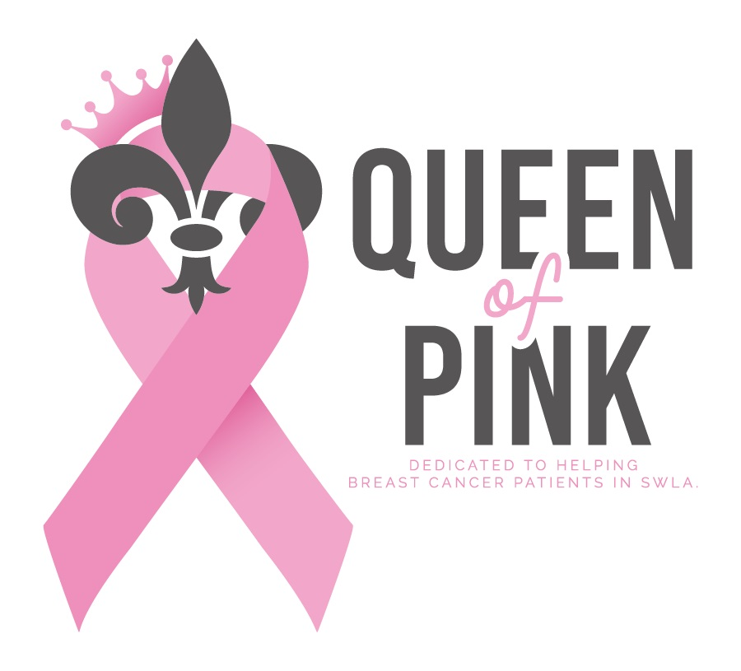
Donation form for the Queen of Pink Organization.
All proceeds go to breast cancer patients in Southwest Louisiana.

Name of Contestant being sponsored___________________________.
Deadline is May 10, 2026

Please mail this form and your donation check to:
Queen of Pink
PO BOX 409
IOWA LA 70647

Name/Business Name: __________________________________________________________________

Mailing Address: ___________________________________________________________________

_____________________________________________________________________________

Email address: __________________________________________________________________

Phone #: ____________________________

Enclosed is my check in the amount of $________________ payable to Queen of Pink.
Please check one: _____No receipt needed _____Email receipt _____Mail receipt

Type of Donation (please choose one):

- General Donation – Business donation (please attach business card if available)
Donations of $300.00 or more will get their business name/logo on Queen of Pink walk t-shirt in October.

- Gift in memory of: ___________________________________________________________
(Name of deceased)

- Gift in honor of: _____________________________________________________________
(Name of individual)

Sign__________________________________________________ Date____________________

Recognition of your generosity will be posted on our website: www.queenofpink.org
------------------------------------------------------------------------------------------------------------------------------------------

Thank you for your contribution to the Queen of Pink Organization, a 501c3 nonprofit organization.
EIN Number: 26-0750103
Your contribution is tax-deductible to the extent allowed by law.

