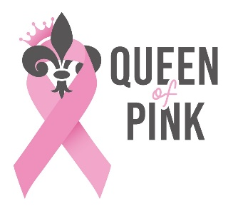
2026
Queen of Pink
Breast Cancer Awareness Walk/Benefit
Sponsor Form

The Queen of Pink Organization is looking for sponsors for our 18th annual Queen of Pink Walk/Benefit to be held at Knights of Columbus Hall located at 503 Hwy 90, Iowa, LA on October 10, 2026. I would like at this time to ask for your support and sponsorship of the event. If you can help us, please fill out the bottom portion of this form and mail it in with your donation or call 337-244-5353 to have it picked up.
Since we are a Non-profit 501(c)3 organization, your sponsorship may also be tax-deductible, so please consult your tax advisor.

Each month The Queen of Pink Organization gives a onetime gift of $500 to an individual that has been diagnosed with breast cancer and who resides in Beauregard, Calcasieu, Allen, Jeff Davis, or Cameron parishes.
For more information on the Queen of Pink Organization, please visit our website:
www.queenofpink.org

Pink Sponsor - $300 or more in Monetary Donations, Gift Cards or Certificates, etc.
•Logo/Name on 2026 walk t-shirt (please email logo to queenofpinkpageant@aol.com)
*Logo/Name on a banner displayed at the event
•Recognition and a link to your website on our website

•Promotional material in participant packet
(Please provide business cards or brochures)
*2 Free Event Registrations with Limited Edition 2025 T-Shirt
(*Please return registration forms with your sponsorship)

Silver Sponsor - $200 in Monetary Donations, Gift Cards or Certificates, Etc.
*Name recognition on 2026 walk t-shirt and banner displayed at the event
•Recognition and a link to your website on our website
•Promotional material in participant packet
(Please provide business cards or brochures)
White Sponsor – up to $100 in Monetary Donations, Gift Cards or Certificates, Etc.

•Recognition on our website
*Recognition in participant packet

Please return the bottom portion of this form with your donation by September 10, 2026.
----------------------------------------------------------------------------------------

Business Name: ________________________________________________________________________
*********Please attach a business card for advertising if available. ********

Full Address: _____________________________________________________________________________________

________________________________________________________________________________________________

Email address: ________________________________________ Website: ____________________________________

Phone #: (_____) _______________________ Contact Person: _____________________________________________

Amount of Donation $________________ - _____ Pink Sponsor _____ Silver Sponsor _____ White Sponsor

Please check one: _____No receipt needed _____Email receipt _____Mail receipt

Please make checks payable to Queen of Pink, PO Box 409, Iowa, LA 70647

Signature____________________________________________________________________________________

The 2026 Queen of Pink Breast Cancer Awareness Walk/Benefit will be held on October 10, 2026. The walk and benefit will be at the Knights of Columbus Hall located at 503 Hwy 90, Iowa, LA. Registration for the walk will begin at 8AM. Opening Ceremonies will begin at 8:30 and the walk will start at 9AM. The benefit will begin at 10AM.
If you have any questions, please feel free to email us at queenofpinkpageant@aol.com
or call/text Alicia Gutierrez at 337-244-5353

