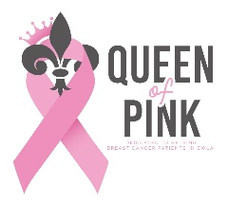
Donation form for the Queen of Pink Organization.
All proceeds go to breast cancer patients in Southwest Louisiana.

Name of Contestant being sponsored___________________________.
Deadline is May 10, 2026

Please mail this form and your donation check to:
Queen of Pink
PO BOX 409
IOWA LA 70647

Name/Business Name: __________________________________________________________________

Mailing Address: ___________________________________________________________________

_____________________________________________________________________________

Email address: __________________________________________________________________

Phone #: ____________________________

Enclosed is my check in the amount of $________________ payable to Queen of Pink.
Please check one: _____No receipt needed _____Email receipt _____Mail receipt

Type of Donation (please choose one):

- General Donation – Business donation (please attach business card if available)
Donations of $300.00 or more will get their business name/logo on Queen of Pink walk t-shirt in October.

- Gift in memory of: ___________________________________________________________
(Name of deceased)

- Gift in honor of: _____________________________________________________________
(Name of individual)

Sign__________________________________________________ Date____________________

Recognition of your generosity will be posted on our website: www.queenofpink.org
------------------------------------------------------------------------------------------------------------------------------------------

Thank you for your contribution to the Queen of Pink Organization, a 501c3 nonprofit organization.
EIN Number: 26-0750103
Your contribution is tax-deductible to the extent allowed by law.

